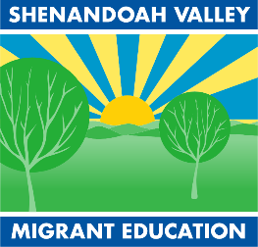
ELIGIBILITY QUESTIONNAIRE
Shenandoah Valley Migrant Education Program
JMU MSC 9007 Harrisonburg, VA 22801
Phone: 540-568-3666 Fax: 540-568-6374
http://www.iihhs.jmu.edu/svmep/
The Migrant Education Program provides support for families that have recently moved to a new county, city, or country who have obtained a job working with agriculture or raw food processing. If you have moved and have found qualifying work after the move, you could qualify for the following free services for your child/children:
In-home tutors to help with homework
Help applying for social services applications like Medicaid or SNAP
Communication with schools regarding your student’s education
Help finding a doctor or a dentist
Transportation and interpretation for medical and dental appointments
Free school Lunch

If you would like to see if you qualify, please give us a call or fill out the following and return it to your child’s school:

1. In the past three years, have you or your spouse worked in (or applied for work in) any of the following jobs:
*** (Please note if you have done any of the following work whether or not it was in Virginia) *** Yes No
- line work in a poultry processing plant (I.e. Cargill, Perdue, Pilgrim’s Pride, George’s, Shenandoah Valley Organic);
- growing or harvesting a crop of fruit, vegetables, or trees (I.e. Shenandoah Growers);
- work on a dairy or poultry farm or in the fishing industry;
- or caring for animals on a farm or ranch

2. When did you move to this county/city? Month Year

Child’s Name Age Grade

Child’s Name Age Grade

Child’s Name Age Grade

3. Parent/guardian information (if student is a minor):

Name Telephone number

Address City Zip Code

Please return this completed form to your student’s school. Thank you!

***Based on the information provided, a Shenandoah Valley Migrant Education Program representative will contact you about the services offered by the Migrant Education Program. Migrant Education is an ESSA Title One, Part C program that provides supplemental educational services to children of migrant agricultural workers, people who have moved to this area (or have moved frequently) to find agricultural work. We specialize in addressing the needs of second language learners who have had interrupted educational histories.

